DLAP Document List Deployment Guide

Change History

| Version # | Date | Modified By | Description |
| --- | --- | --- | --- |
| 1.0.0.0 | 01/24/2018 | Ashok Pudota | Initial DLAP Document List Deployment |
| 2.0.0.0 | 03/28/2018 | Ashok Pudota | Implemented Versioning 2.0.0.0  Updated Document List Response mapping. |
| 2.0.0.1 | 03/29/2018 | Ashok Pudota | Updated Deployment Version from 2.0.0.0 to 2.0.0.1  Updated Document List Response Mapping for Applicant ID. |
| 2.0.0.2 | 04/02/2018 | Ashok Pudota | Updated Deployment Version from 2.0.0.1 to 2.0.0.2  Updated Application Document Details STATUS mapping. |
| 2.0.0.3 | 04/11/2018 | Ashok Pudota | Updated Deployment Version from 2.0.0.2 to 2.0.0.3  Updated Content Version Mapping for DLAP_Document_Type__c. |
| 2.0.0.4 | 05/11/2018 | Ashok Pudota | Updated Deployment Version from 2.0.0.3 to 2.0.0.4  Updated Closed Documents Mapping |
| 2.0.0.5 | 05/11/2018 | Ashok Pudota | Updated Deployment Version from 2.0.0.4 to 2.0.0.5  Fixed Mapping issues. |
| 2.0.0.6 | 05/23/2018 | Ashok Pudota | Updated Deployment Version from 2.0.0.5 to 2.0.0.6  Fixed -DCMM-3693 |
| 2.0.1.0 | 05/25/2018 | Ashok Pudota | Updated Deployment Version from 2.0.0.6 to 2.0.1.0  Fixed -DCMM-3849  Fixed -DCMM-3848 |
| 2.0.1.1 | 05/25/2018 | Ashok Pudota | Updated Deployment Version from 2.0.1.0 to 2.0.1.1  Updated Mapping for DLAP Document Type. |
| 2.0.1.2 | 05/31/2018 | Ashok Pudota | Updated Deployment Version from 2.0.1.1 to 2.0.1.2  Fixed Following Issue:  DCMM-3849 |
| 2.0.2.0 | 06/07/2018 | Ashok Pudota | Updated Deployment Version from 2.0.1.2 to 2.0.2.0  Fixed Following Issue:  Updated Application Mapping for the Account object.   * DCMM 3851 * DCMM 3594 * DCMM 4098 * DCMM 4099 |
| 2.0.4.0 | 06/14/2018 | Ashok Pudota | Updated Deployment Version from 2.0.2.0 to 2.0.4.0  Fixed Following Issue:   * DCMM 3702   Removed CDATA and Implement REST service for Documents |
| 2.0.4.5 | 07/03/2018 | Ashok Pudota | Updated Deployment Version from 2.0.4.0 to 2.0.4.5  Fixed Following Issue:   * DCMM 4379   Updated Application Document Info |
| 2.0.8.1 | 08/28/2018 | Ashok Pudota | Updated Deployment Version from 2.0.4.5 to 2.0.8.1  Fixed Following Issue:   * DCMM-5249   Removed CDATA Ports |
| 2.0.9.5 | 10/10/2018 | Ashok Pudota | Updated Deployment Version from 2.0.8.1 to 2.0.9.5  Fixed Following Issues  DCMM-5615  Updated Mapping to send Finalized Documents to the DLAP |

**Contents**

1. **Special Notes……………………………………………………………………………………………………………………….2** 
   1. **Username and Password instructions……………………………….…………………………………….2**
2. **Initial Deployment instructions ……………………………………………………………………………………………3**
3. **Re-Deployment** **instructions………………………………………………………………………………………………….6**

Special Notes:( DLAP Username and Password update instructions)

|  |  |  |
| --- | --- | --- |
| **Environment** | **DALP Update** | **Location** |
| DEV-INT | **Credentials**: Test  **UserName:** Dlap  **Password:** Basic2017 | Create a **local User** on server machine with username and password. |
| QA | Credentials: **N/A**  **check with Steven** | Create a **local User** on server machine with username and password. |
| PROD | Credentials: **N/A**  **check with Steven** | Create a **local User** on server machine with username and password. |

Username and Password update instructions:

1. Open **Local Users and Groups** on System Tools and Create **Username** and **Password**. for Dlap Service.

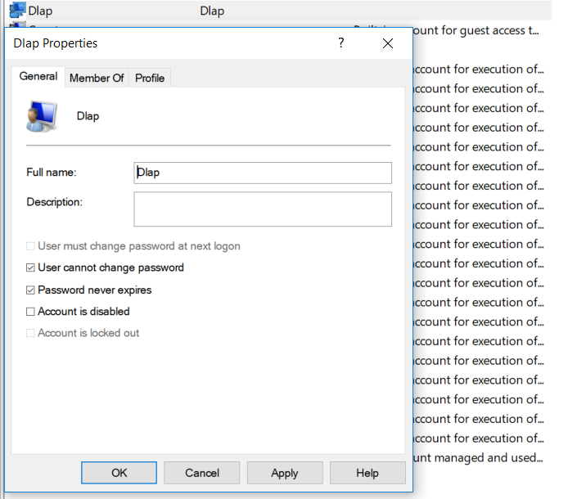

Initial Deployment Summary:

**Msi Installation:**

1. Open BizTalk Administration console and Import/Install the **DLAP Document List.msi** into the **Small Business Administration** application then complete the wizard by clicking Finish button and check mark the option Run Application Installation Wizard again to Install the MSI.
2. Next, import the **DLAP Document List Binding Info.xml** binding file after updating **Salesforce** send port configuration into the **Small Business Administration application.**
3. Start all the BizTalk artifacts related to **DLAP Document List**.

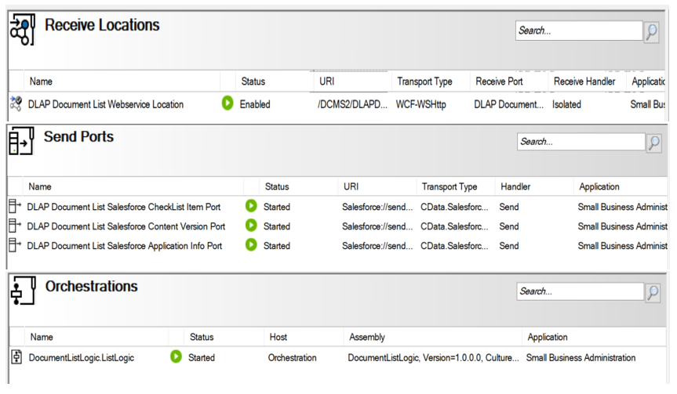

1. **Restart** All the **Host-instances.**
2. Open **IIS** (Internet Information System) right click on **DLAP Document List** Website and validate appropriate **Application Pool** (i.e. **DLAP Document List**) is selected.
3. Next, select **DLAP Document List** Website and go-to Authentication page on IIs and make sure **Basic Authentication** is **enabled** and remaining all are disabled as shown in the below screen-shot.

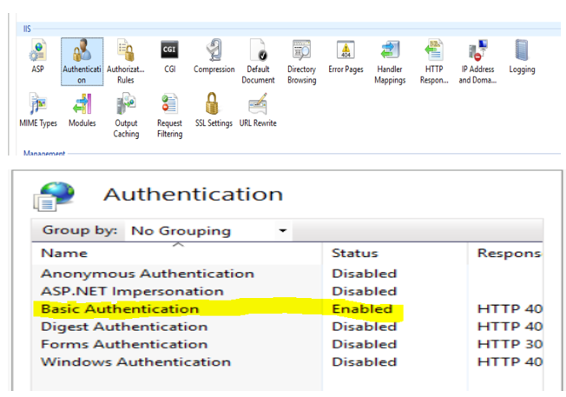

1. Next, Select **Authorization Rules** page on IIs and make sure only **Dlap User** is allowed as shown in the below screen-shot.

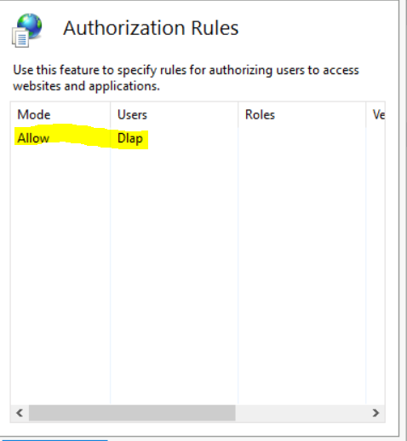

1. Reset/Re-start **IIS** (Internet Information System).
2. Browse the following **DLAP Document List** (HTTPS://) Website and make sure the site is up-running.

**Validate Application Being Deployed:**

1. Go to **BizTalk Administrator Console**, make sure **all** BizTalk artifacts related to **DLAP Document List Interface** are up-running.
2. Open **DLAP Document List Receive Location** and validate security properties as shown below.

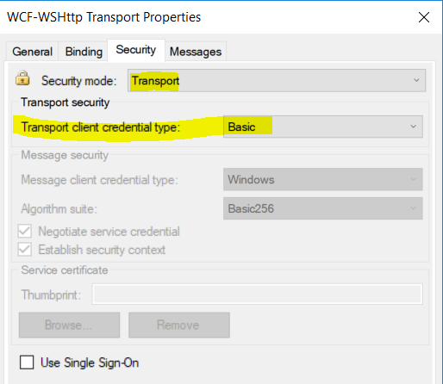

1. Go to **IIS**, make sure IIS is started.
2. Browse the **DLAP Document List** web site (HTTPS://) and make sure the site is up-running.
3. Open Soap-UI project attached on Deployment folder and post the sample message.

Re-Deployment instructions:

**Msi Installation:**

1. Go to BizTalk Administration console **stop and Unenlist all** the BizTalk artifacts related to **DLAP Document List Interface:**

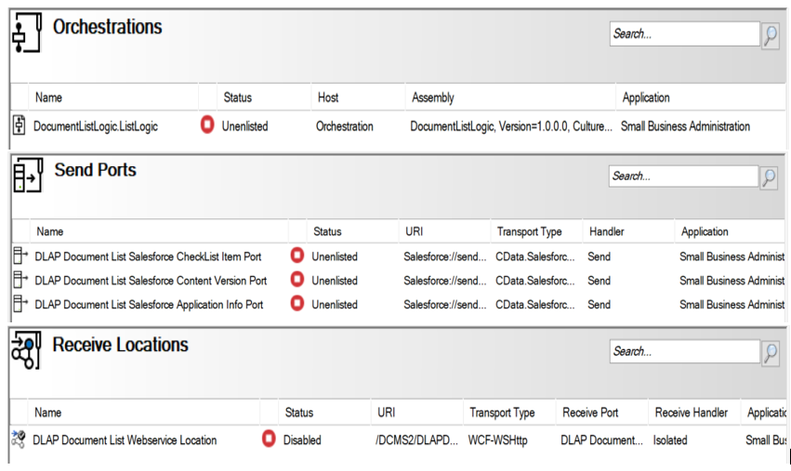

1. Remove Old Assemblies 2.0.8.1 and WEB Directory as show in the below screen-shot.

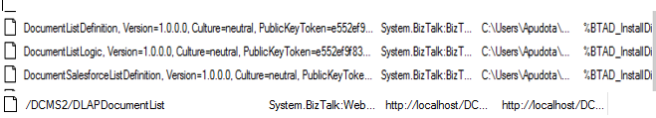

1. Ports Cleanup (Unenlist and Remove following CDATA send ports):

* DLAP Document List Salesforce CheckList Item Port
* DLAP Document List Salesforce Application Info Port

1. Next, Open **BizTalk Administration console** and **Import/Install** the **DLAP Document List 2.0.0.2.xmsi** into the **Small Business Administration** application then complete the wizard by clicking **Finish** button and check mark the option **Run Application Installation Wizard** again to Install the MSI.
2. Next, import the **DLAP Document List Binding Info.xml** binding file after updating **Salesforce** send port configuration into the **Small Business Administration application.**
3. **Start** all the **BizTalk artifacts (i.e. Receive location, Send ports and Orchestration)** related to **DLAP Document List** Interface.
4. **Restart** All the **Host-instances**.
5. Open **IIS** (Internet Information System) right click on **DLAP Document List** Website and validate appropriate **Application Pool** (i.e. **DLAP Document List**) is selected.
6. **Reset/Re-start IIS** (Internet Information System).
7. Browse the following **DLAP Document List** (HTTPS://) Website and make sure the site is up-running:

**Validate Application Being Deployed:**

1. Go to BizTalk Administrator Console, make sure **all** BizTalk artifacts related to **DLAP Document List** Interface are up-running.
2. Go to IIS, make sure IIS is started.
3. Browse the DLAP Document List web site (HTTPS://) and make sure the site is up-running.
4. Open Soap-UI project attached on solution Items folder and post the sample message.

# **DLAP Document List Release Instructions**

Interface Name: **DLAP Document List v2.0.9.5**

BitBucket Brach: **Ashok**

Path: **dcms2-integ-dev-2.0 \DLAP Document List\Deployment\2.0.9.5**

**Msi: -**[DLAP Document List 2.0.9.5.msi](http://dccpw12odaapp02:7990/projects/DCMS2INT/repos/dcms2-integ-dev-2.0/browse/DLAP%20Application%20Import/Deployment/2.0.7.2/DLAP%20Application%20Import%202.0.7.2.msi?at=refs%2Fheads%2FAshok)

**Bindings: DLAP Document List Binding Info 2.0.9.5.xml**

**Pre-Deployment**

Remove existing DLAP Document List resources:

1. Unenlist the following Orchestrations, then Remove them:

* DLAPDocument.ListLogic

1. Remove the following DLAP Document List Resources:

* DLAPDocumentListDefinition v2.0.8.1
* DLAPDocumentListLogic v2.0.8.1
* DLAPDocumentListSalesforceDefinition 2.0.8.1

**Replacements (4-Rest Send Ports)**

* {SFRESTADDRESS}